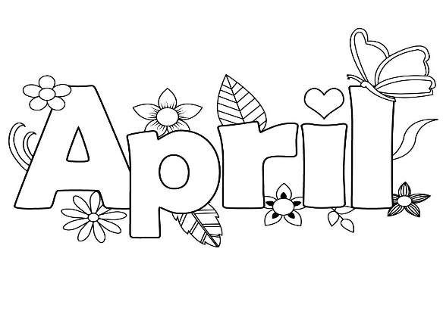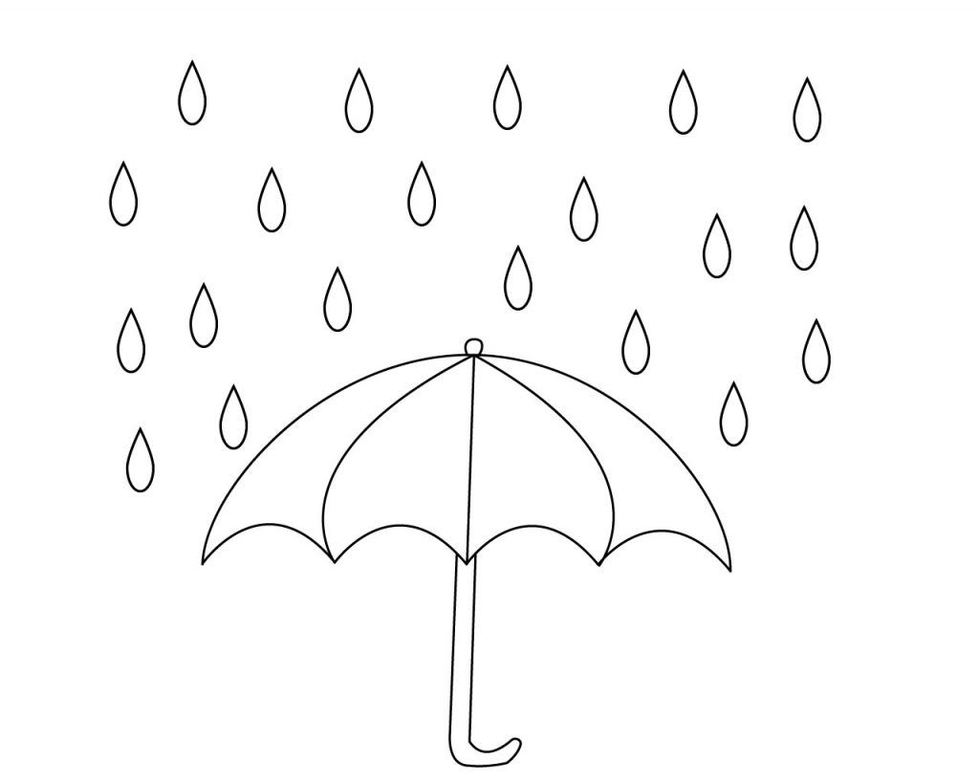

Color one rain drop for every day you read! Due at the end of April for a small treat.

Parent Signature__________________________________________________